Please follow these steps once logged into the system:
Click on Professional Development tab | 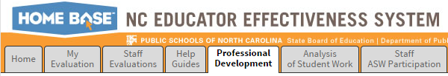
Type title of module in Search box and click Search | 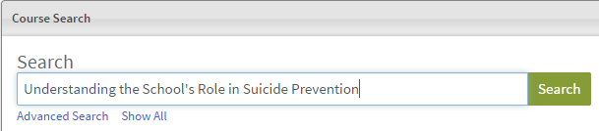
Click on title of the module | 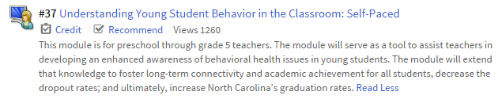
Click on module title | 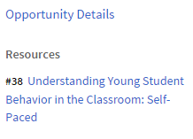
Click on Start or View Again

