Please follow these steps:
Go to: https://center.ncsu.edu/ncpd/​
Click on Login in the top right of the screen
Create a New Account at bottom right of the screen IF you do not have a Moodle account within NC State University  You will receive an email with a link to authenticate the new account. | 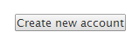
With an authenticated account log back into the site | https://center.ncsu.edu/ncpd/​
You will be prompted to log in through NC Education. After you log in you will be brought back to the NC Education PD page. | 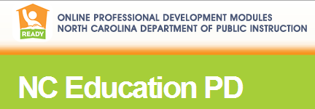
The module titles should be found on the opening page of the site. Click on the module title to enroll in the course. There will be a button to self-enroll.

